**User Guide: Grafana Dashboard**

**1. Overview**

The **Node Exporter Full** dashboard is a widely used community dashboard for monitoring Linux hosts with **Prometheus Node Exporter**.

It provides real-time visibility into:

* CPU usage
* Memory consumption
* Disk space and I/O performance
* Network traffic and errors
* System load averages and uptime

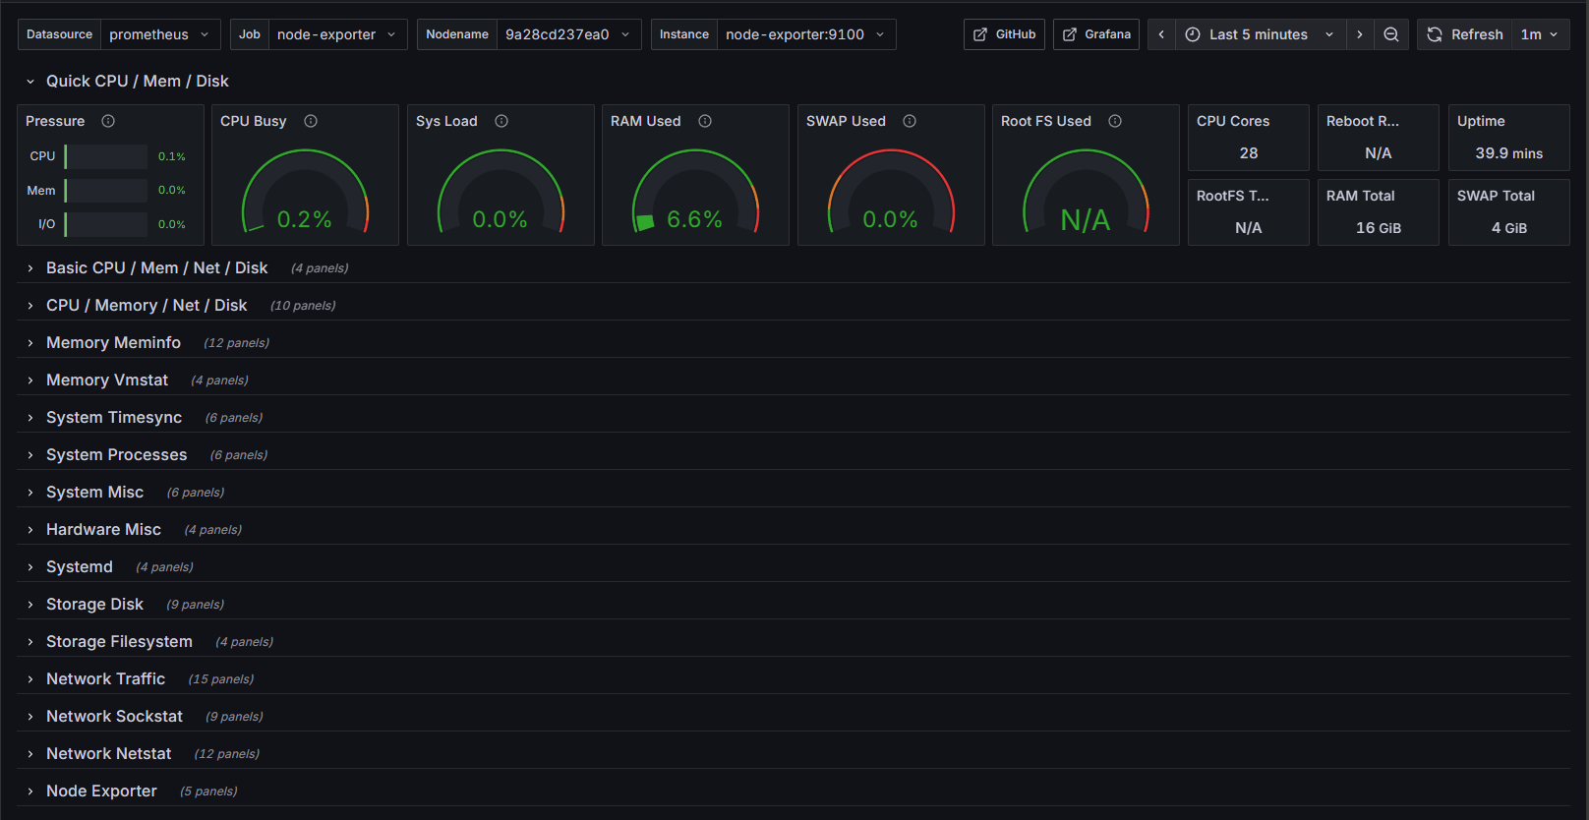This dashboard is designed for **system administrators, DevOps engineers, and developers** to monitor the health and performance of infrastructure.

**2. Dashboard Variables and Filters**

At the top of the dashboard, you will find several **drop-down filters (templating variables)** that allow you to control the scope of the displayed metrics:

* **Datasource (DS_PROMETHEUS)** – Select which Prometheus instance to query.
* **Job (job)** – Typically set to node-exporter, but can be changed if multiple jobs are available.
* **Node Name (nodename)** – Human-readable name of the host/server.
* **Node (node)** – The Prometheus scrape target (e.g., node-exporter:9100).

 These filters make the dashboard reusable across many nodes and environments.

**3. Panels and Metrics**

The dashboard is divided into logical sections:

**3.1 Quick System Summary**

* **CPU Busy** – Percentage of CPU utilization.
* **System Load** – Current load averages (1m, 5m, 15m).
* **RAM Used** – Memory usage percentage.
* **Swap Used** – Swap space usage.
* **Root FS Used** – Usage of the root filesystem.
* **CPU Cores** – Number of CPU cores detected.
* **Uptime** – Time since last reboot.

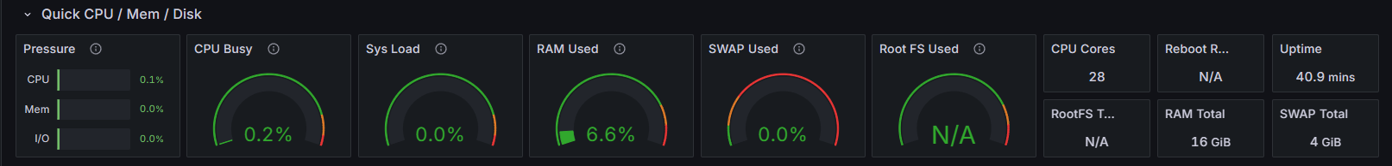

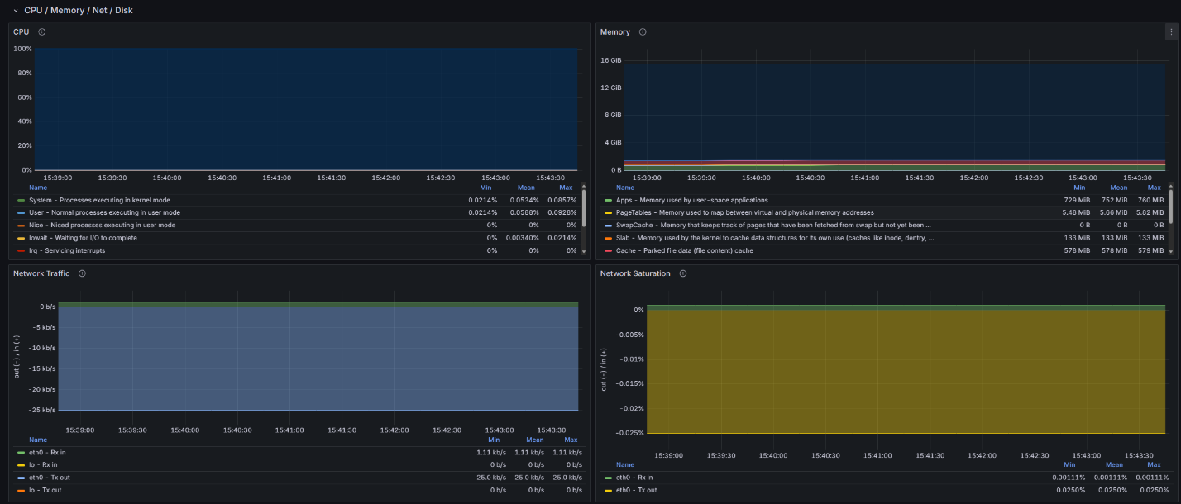**3.2 CPU/Mem/Net/Disk**

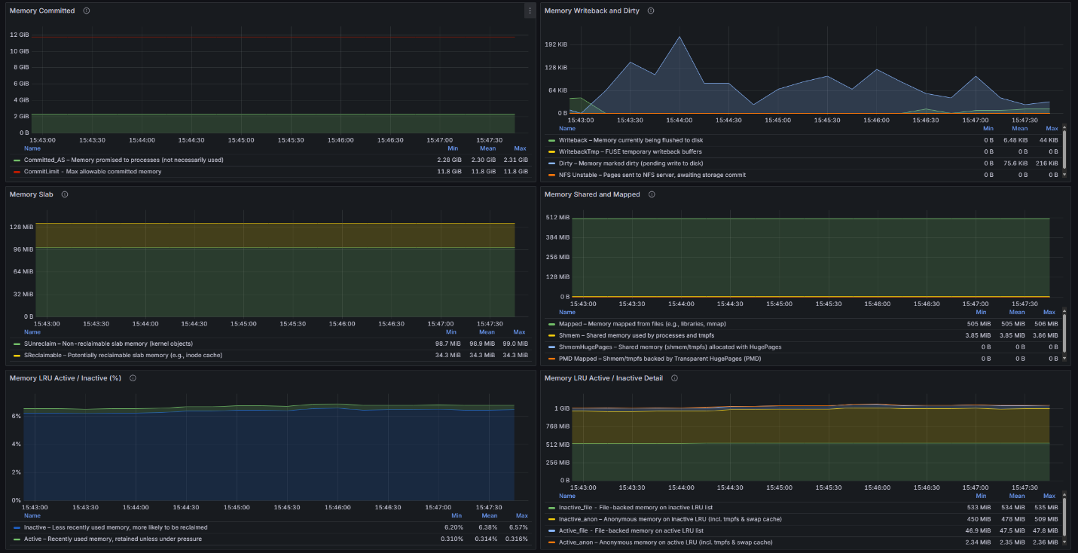**3.3 Memory Metrics**

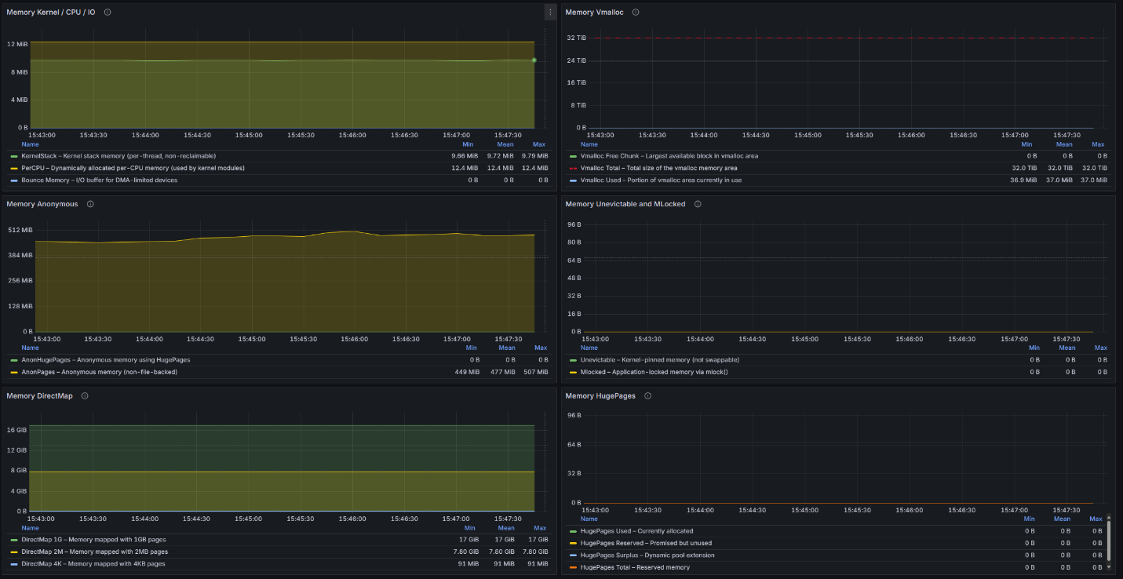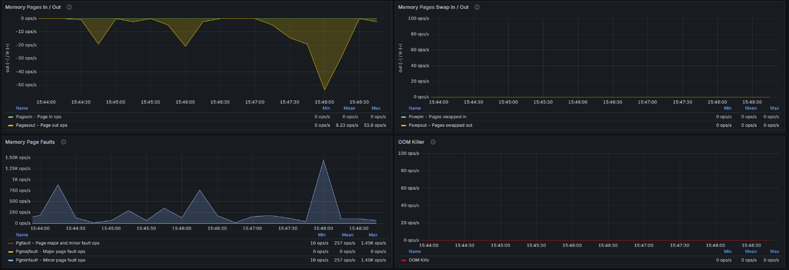

**3.4 Disk Metrics**

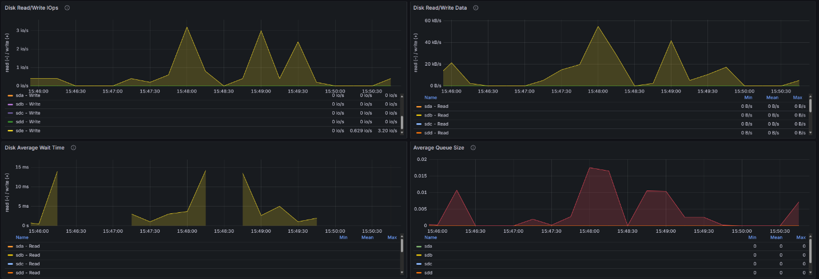

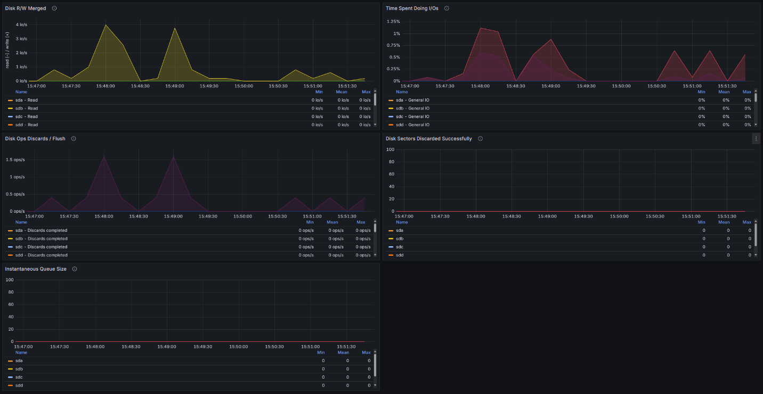

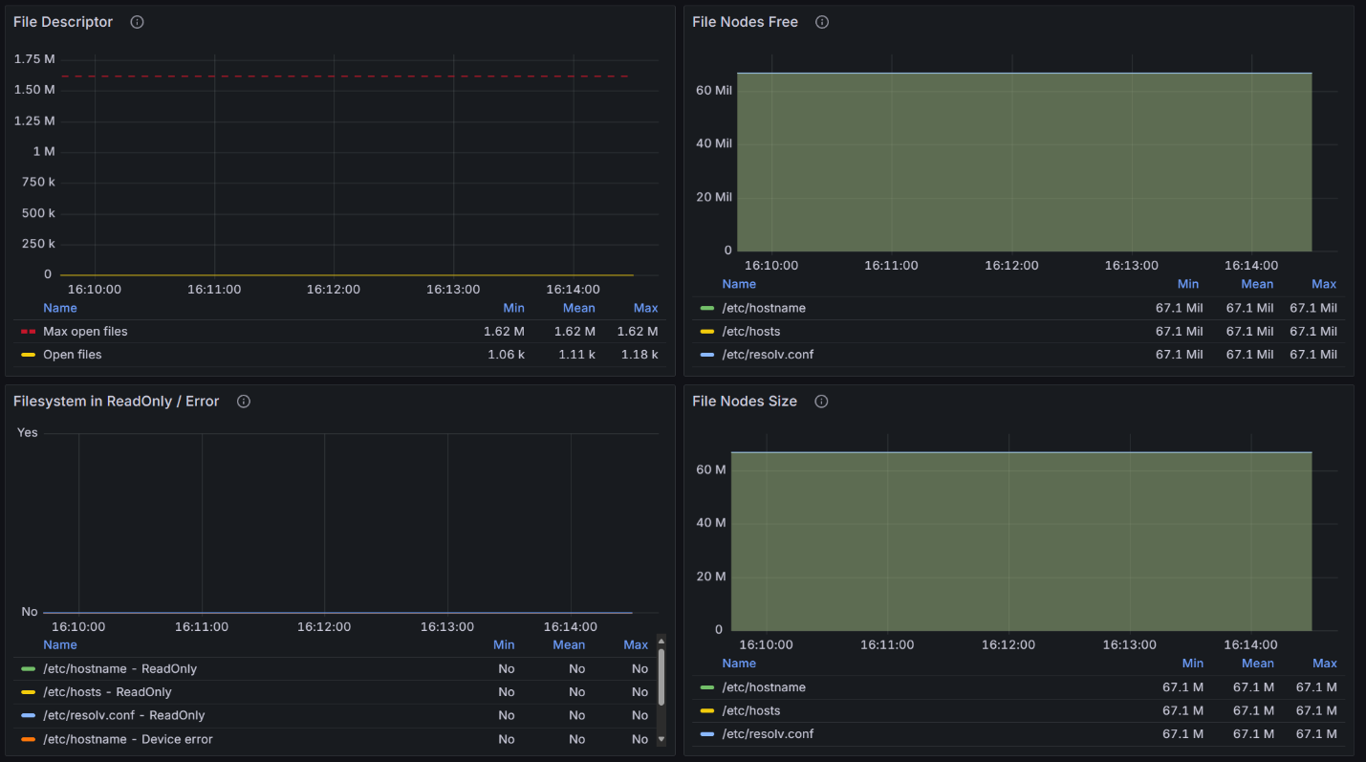

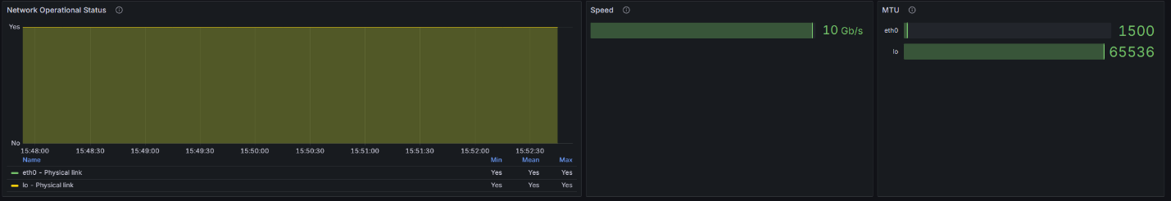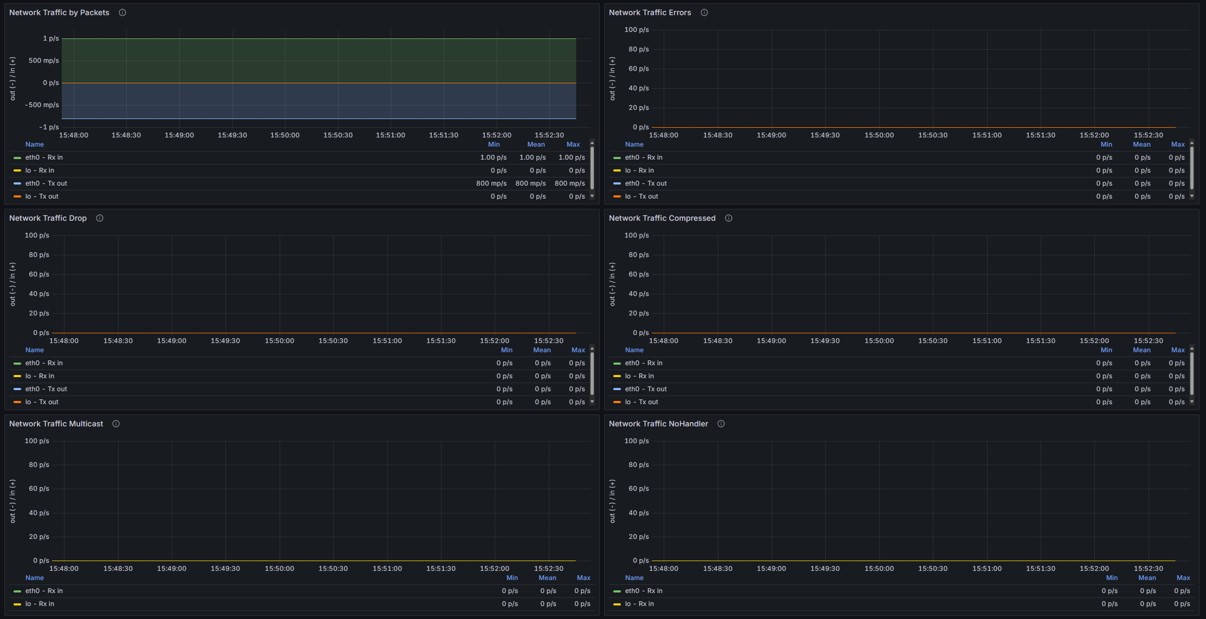**3.5 Network Metrics**

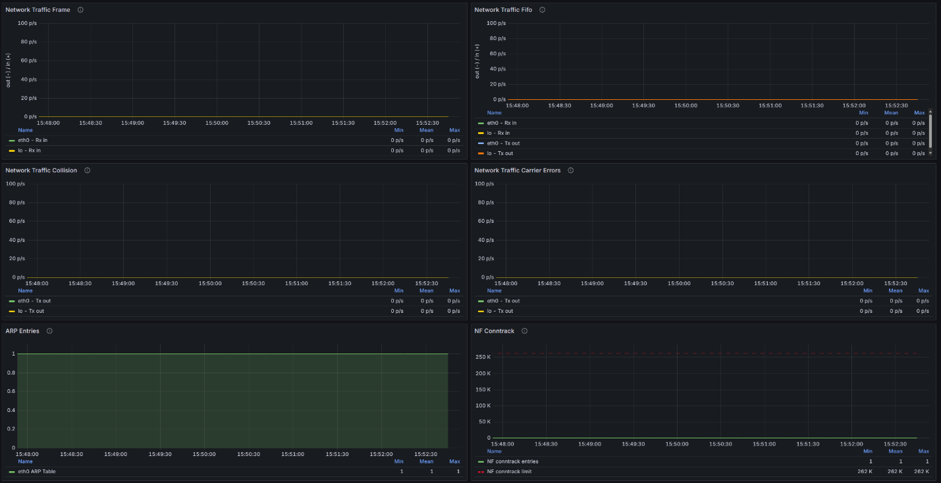

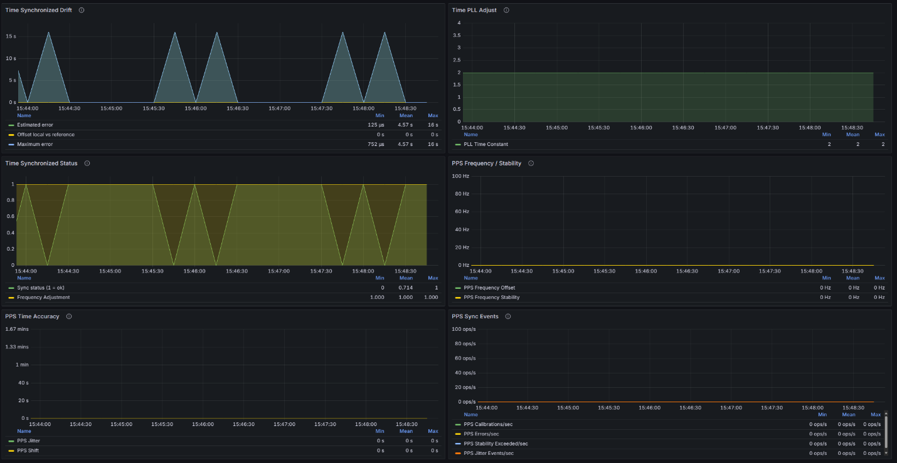**3.6 System Load and Processes**

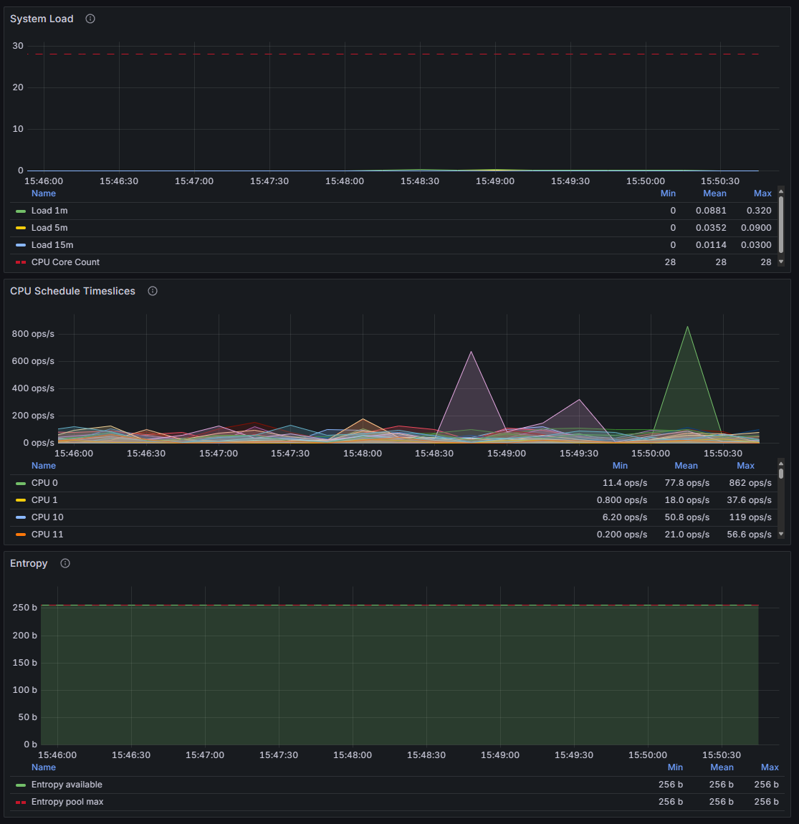

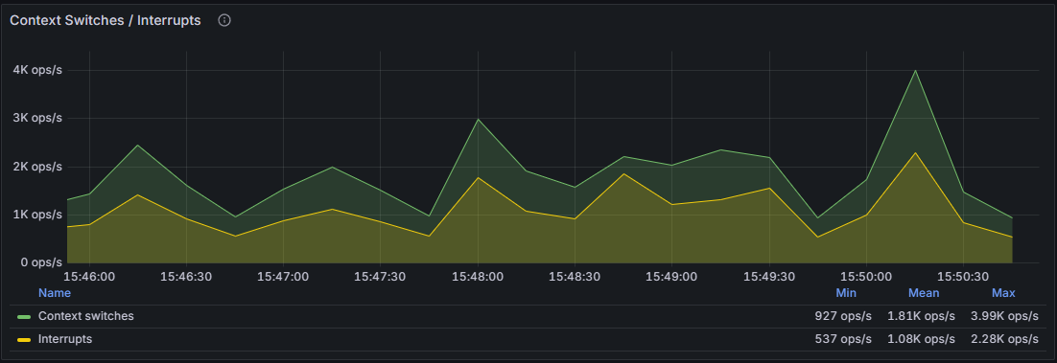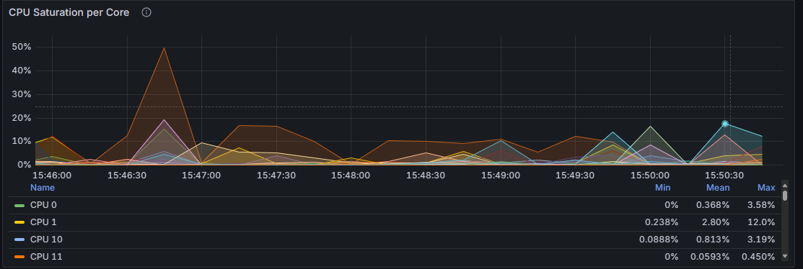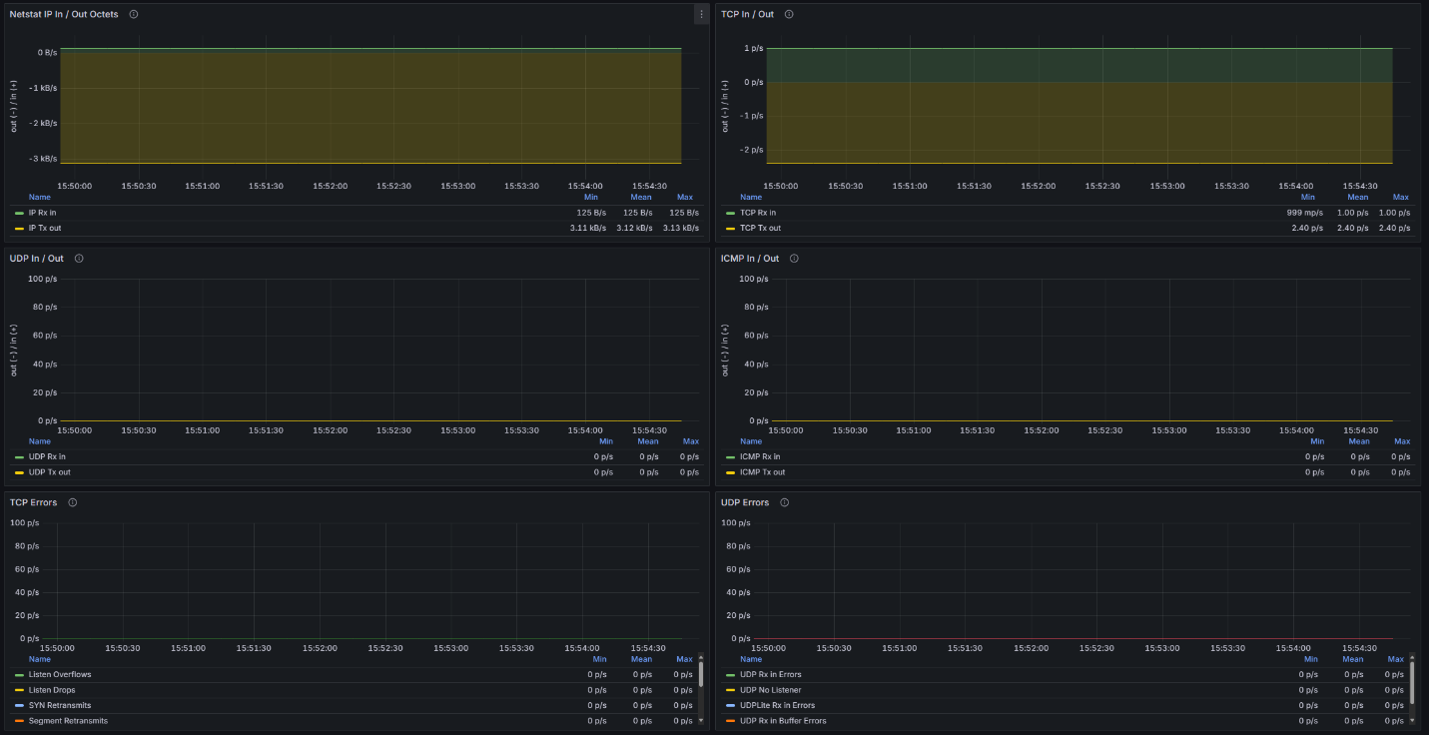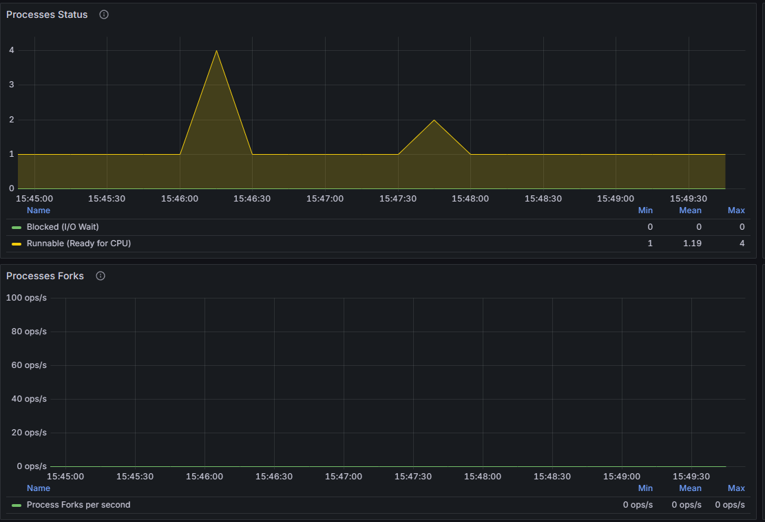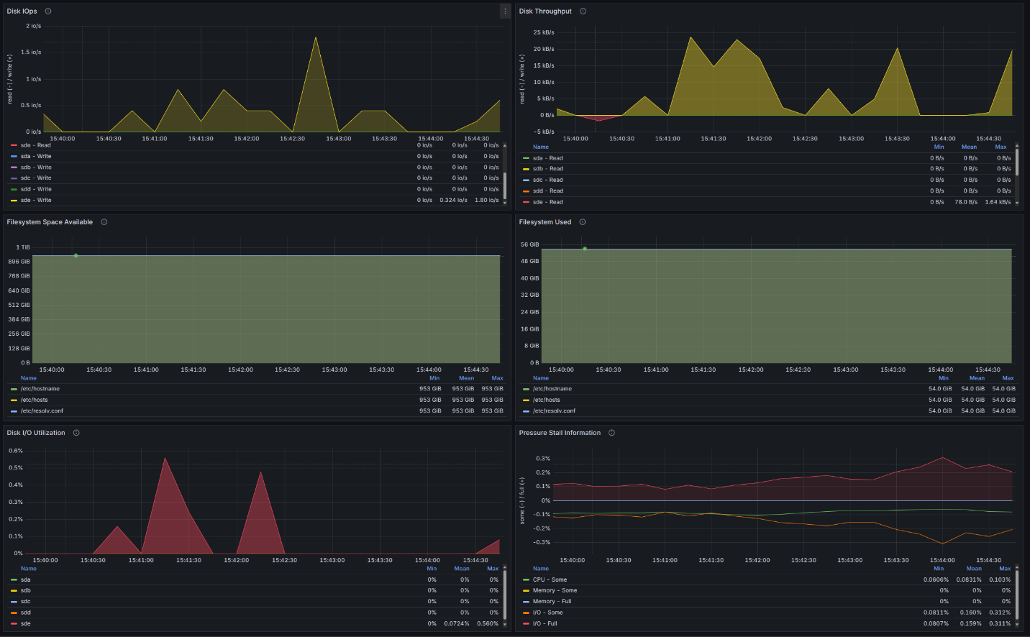

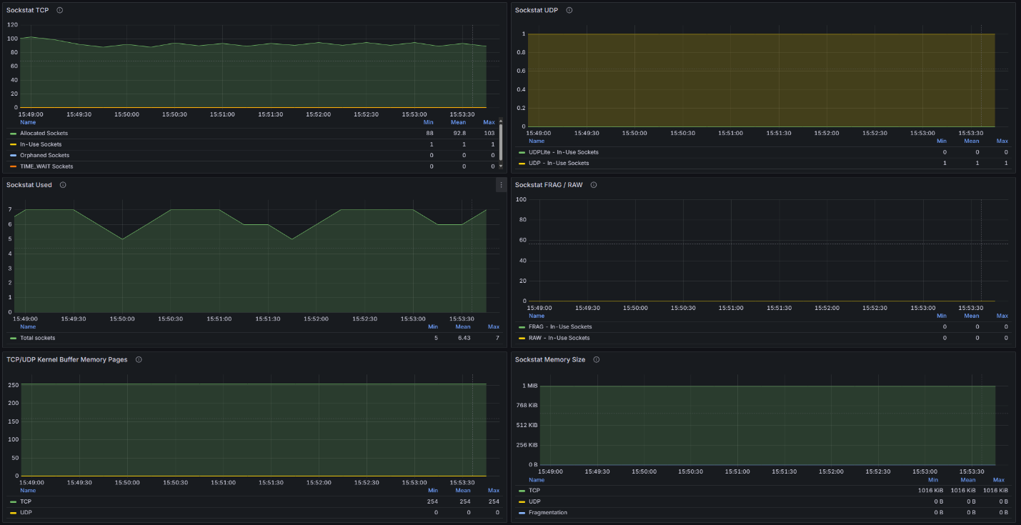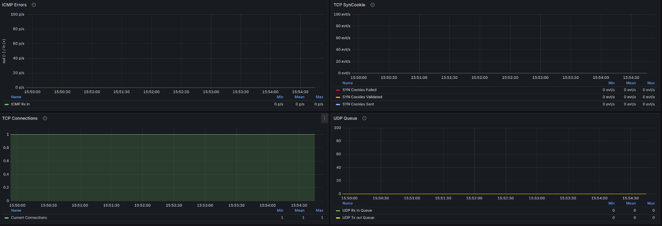

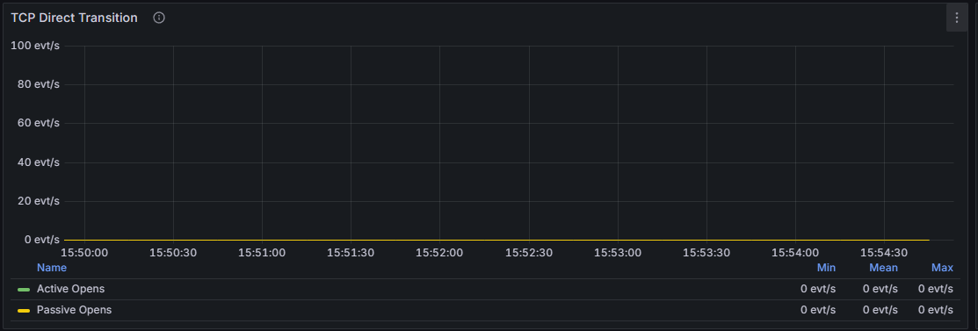

**4. Alerts and Notifications**

By default, this dashboard provides visualization only. Alerts must be configured separately in Grafana or Prometheus Alertmanager. Contact your system administrator if you need alerting enabled.

**5. Troubleshooting**

- If panels show 'N/A' or 'No data':  
 * Ensure Prometheus and Node Exporter are running.  
 * Check the datasource settings.  
- If dashboard does not refresh: Verify `refresh=5s` in the URL or use the refresh dropdown.  
- If wrong node/instance appears: Change filters at the top.  
- If access fails: Confirm Grafana is running on port 3001 and credentials are correct.

**6. Contact Information**

For assistance, contact your system administrator, DevOps, or Grafana support team.